**Assessment- 1**

By-

Ayush Solanki

**LIST OPERATION:**

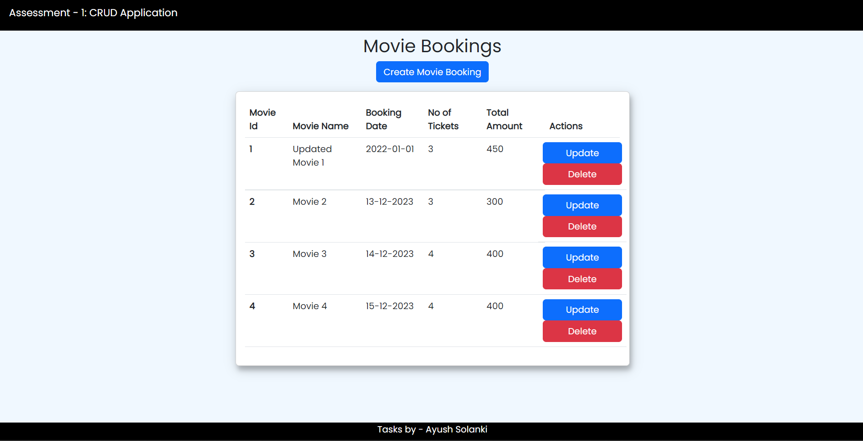

**CREATE OPERATION:**

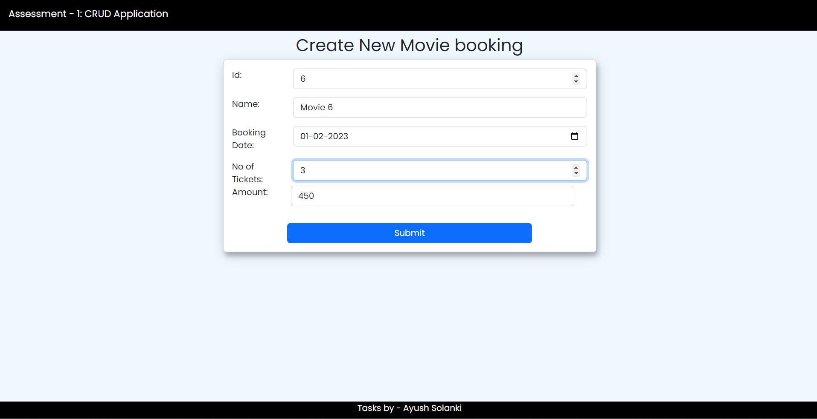

AFTER CREATION NEW OBJECT IS ADDED TO THE LIST AND DISPLAYED

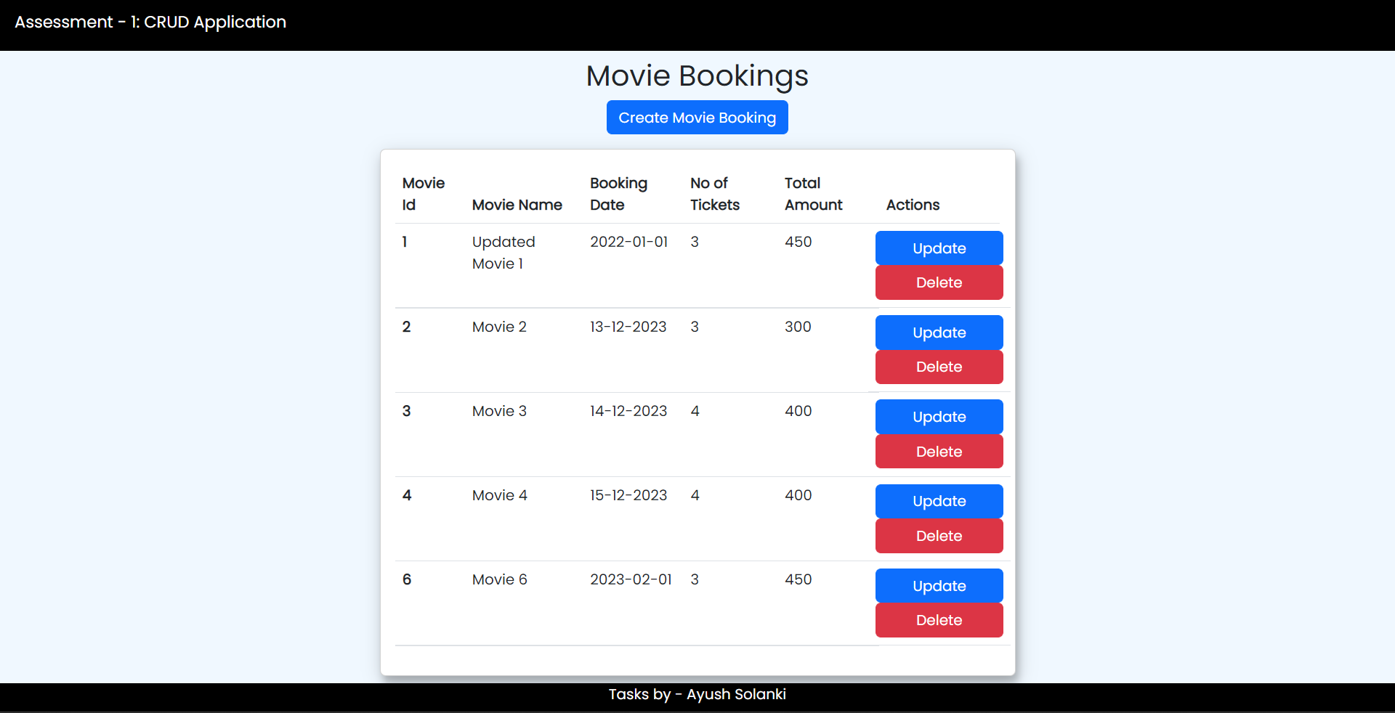

ADDED JSON SERVER TO THE APPLICATION FOR POST, PUT AND DELETE OPERATION

TO RUN THE SERVER

json-server –watch src/assets/moviebooking.json